**Batch name: WiproNGA_DWS_B5_25VID2550**

**Name: Jyoti Sahebrao Jagtap**

**User ID: 34750**

**Emai : jyotishinge60@gmail.com**

**Date:12/8/2025**

**Assignment-7**

**Topics Covered**

* **PowerShell App Deploy Toolkit Understand basic platform value, concepts and usage**
* **Overview of the Tool**
* **Folder Structure**
* **Tool Configuration**
* **Template Script**
* **Predefined Environment Variables defined within Script and its usage**
* **Commands for Installation/Uninstallation**

* **Steps to deploy Application Using Power Shell Application Deploy Toolkit**
* **Download the latest version PSAppDeploymentToolkit_Template_V4.zip file**

**from github account**

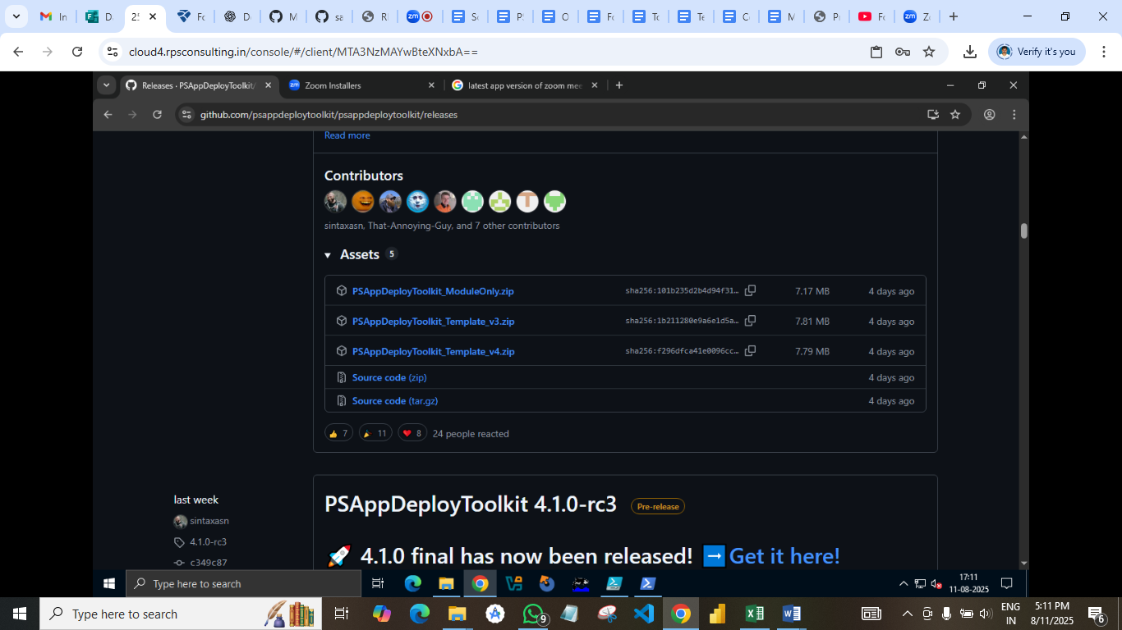

* **Extract all the files and folders of .zip file into new folder**

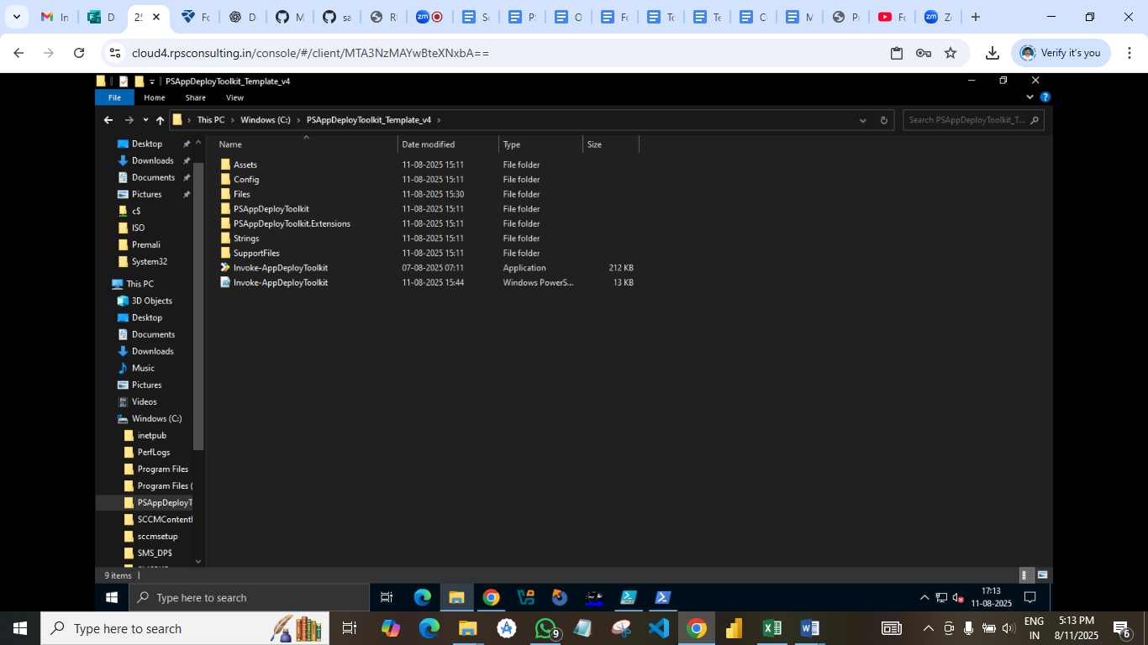

* **download any application with .msi extension then place it in the files folder**

**( I installed zoomInstaller.msi)**

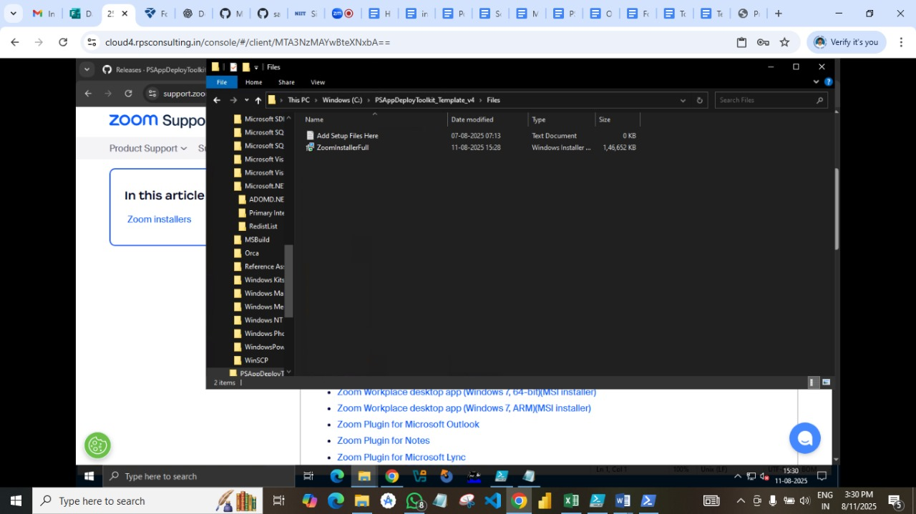

* **Now edit Invoke-AppDeployToolkit.ps1**

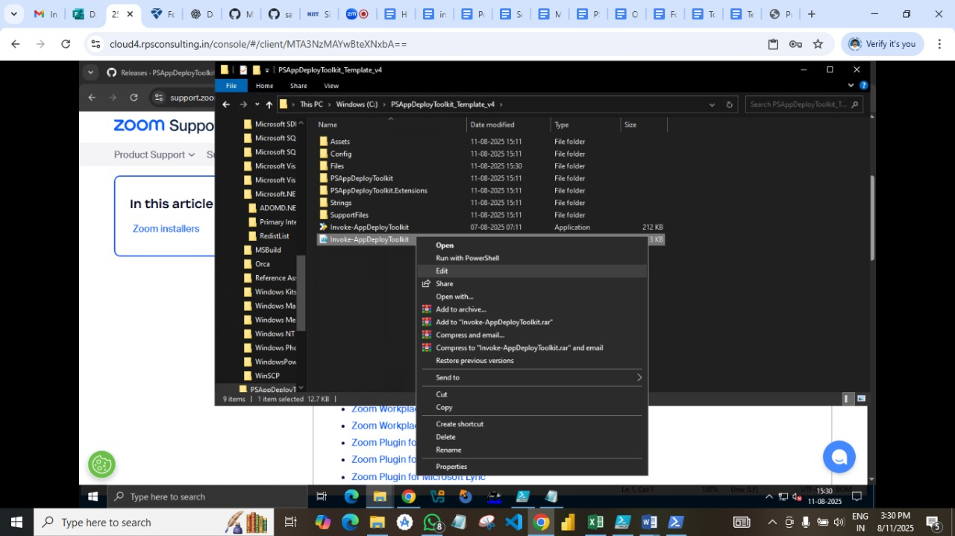

* **Fill all the details Related to Application such as App Vendor, App Version ,**

**App Name etc.**

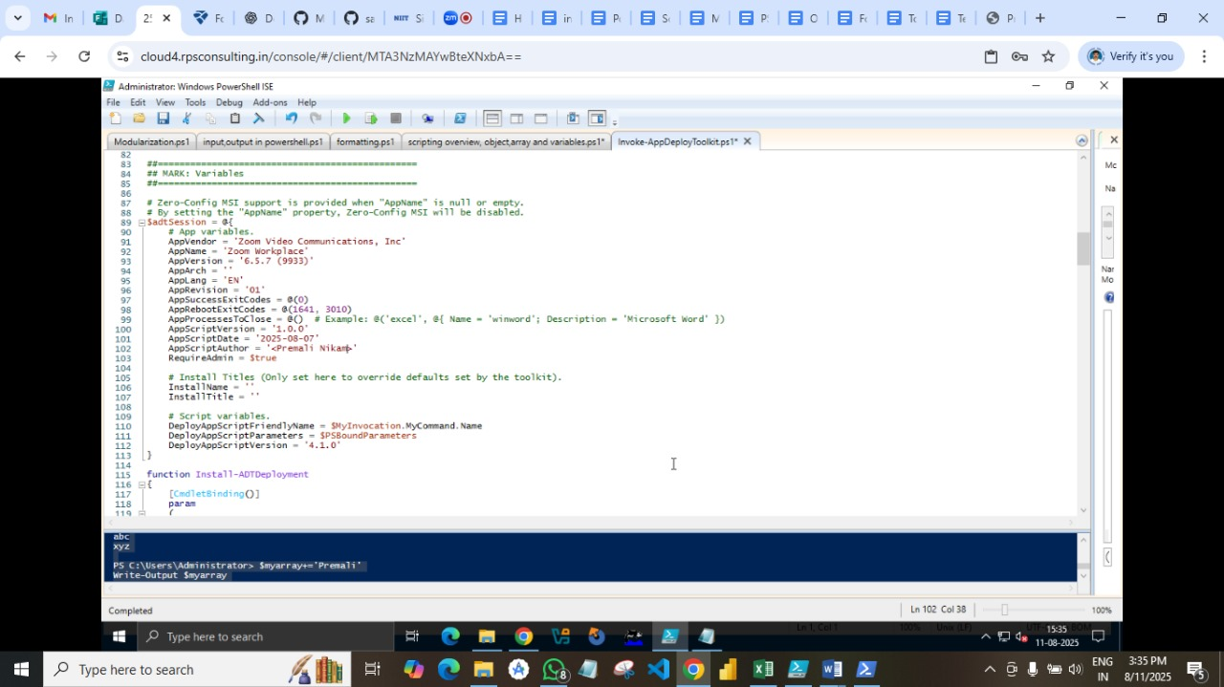

* 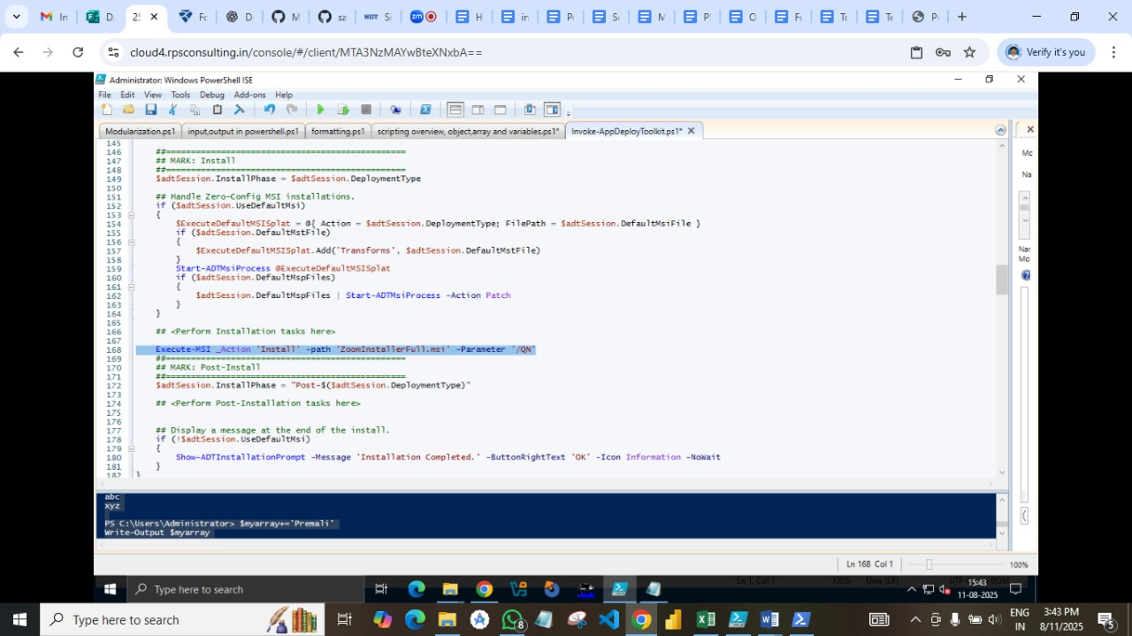**Write install and uninstall commands**

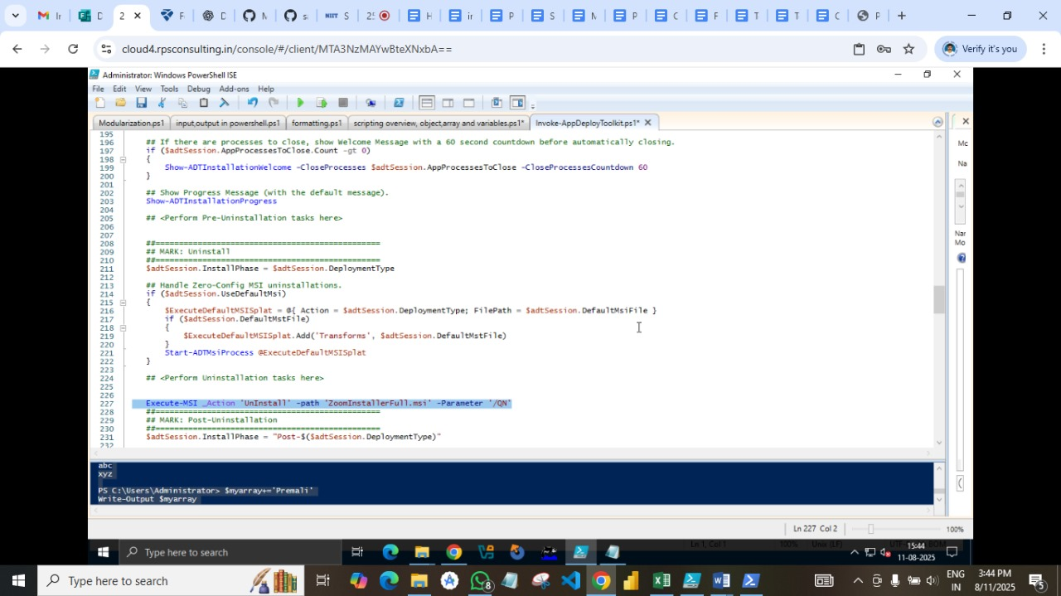

* **Save power shell command and run Invoke-AppDeployToolkit as Administrator**

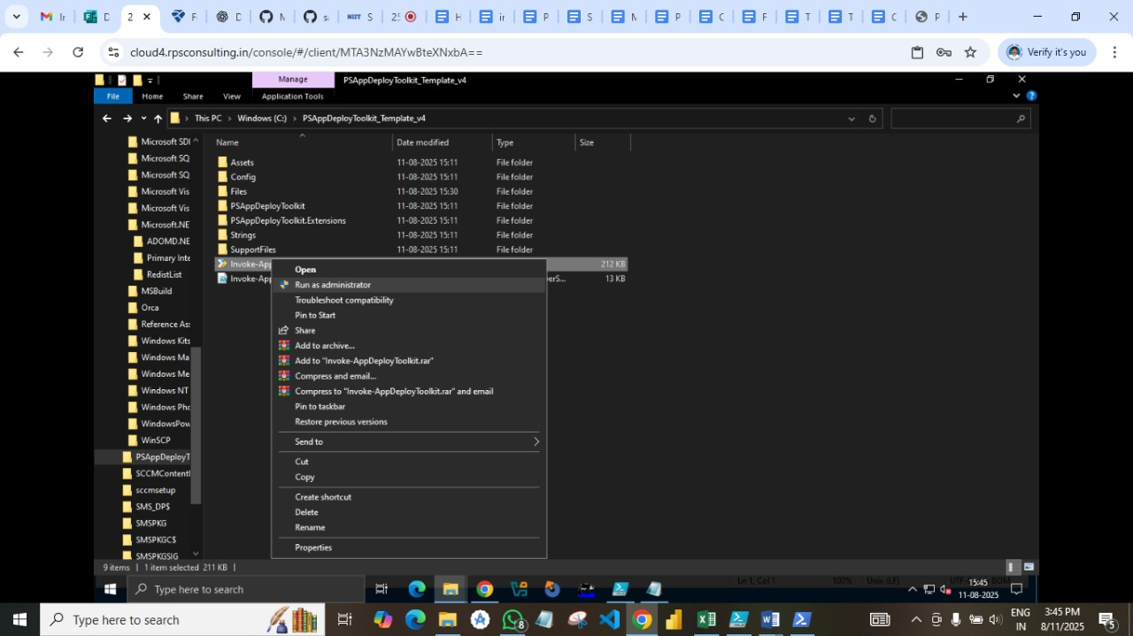

* **Open Power shell as administration. Redirect to the PSADT using cd command.**

**Run the command - .\Invoke-AppDeployToolkit.exe Install.**

**Click on Install.**

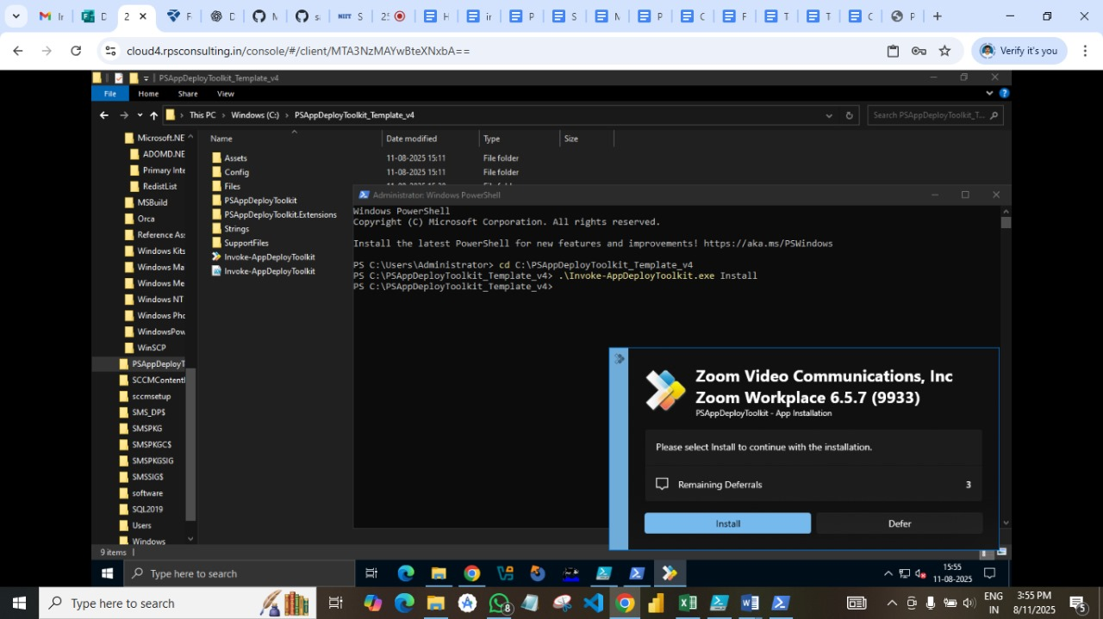

**­**

* 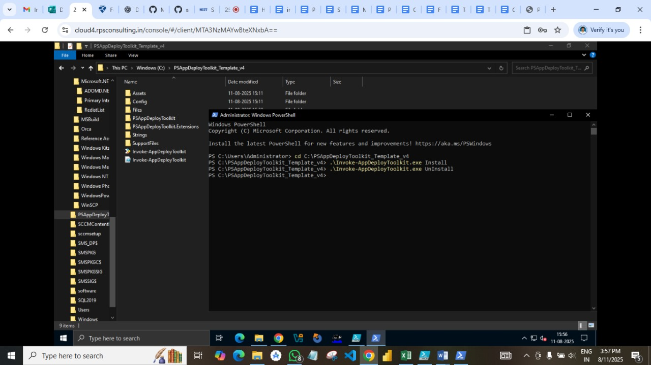**Run the command - .\Invoke-AppDeployToolkit.exe UnInstall. To uninstall application.**
* **Now check the processes done in Log**

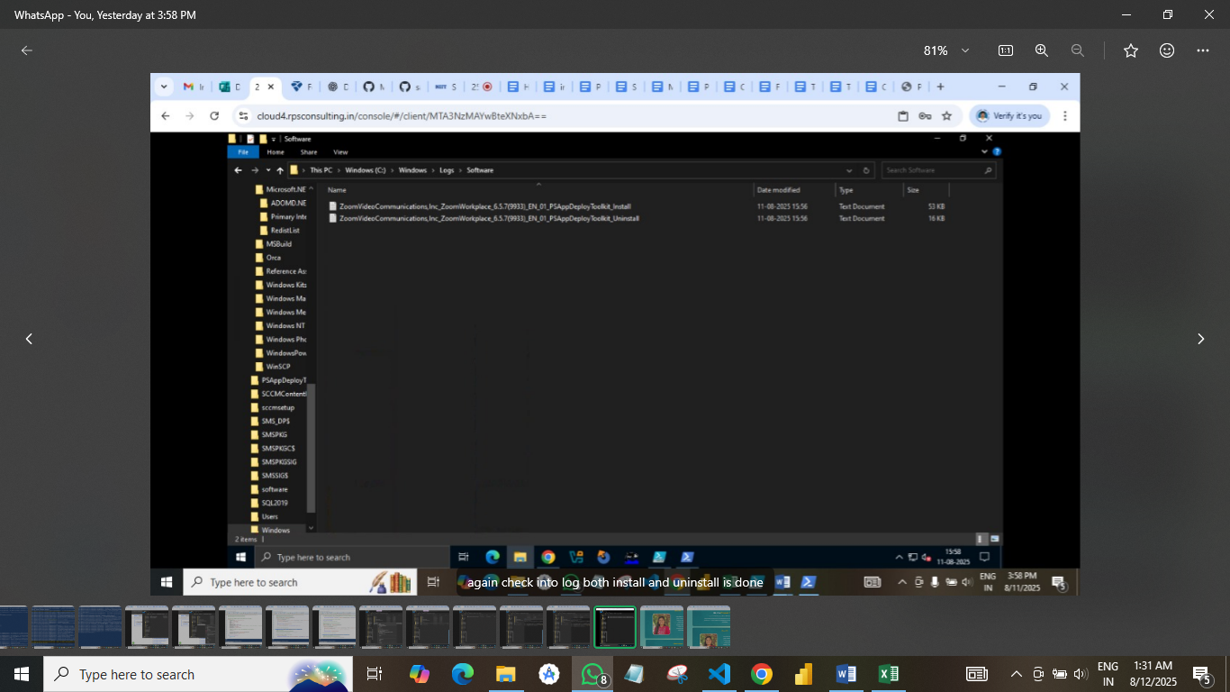

* **Commands for Installation/Uninstallation**
* **Install Command**

**Execute-MSI -Action ‘Install’ -path ‘ZoomInstallerFull.msi’ -Parameter ‘/QN’**

* **UnInstall Command**

**Execute-MSI -Action ‘UnInstall’ -path ‘ZoomInstallerFull.msi’ -Parameter ‘/QN’**

* **Folder Structure**

**• Deploy-Application.ps1 → Your main script. You edit this to define:**

**Install (Install-Application)**

**Uninstall (Uninstall-Application)**

**Repair (Repair-Application)**

**• Files\ → The main app installer(s) you want to deploy.**

**• SupportFiles\ → Any supporting scripts, registry files, or extra configs.**

**• Logs\ → Deployment logs (created automatically).**

**• AppDeployToolkit\ → Core engine — contains Invoke-AppDeployToolkit.ps1 (called internally).**

* **Deploy-Application.exe: This is a wrapper for the Deploy-Application.ps1 script. It ensures that the correct PowerShell execution policy is set.**
* **Key Features and Benefits:**
* **Standardized Deployment Process: PSADT provides a consistent framework for deploying applications, making the process more reliable and easier to troubleshoot. [2, 2, 4, 4]**
* **Pre- and Post-Installation Actions: It allows for performing actions before and after the main installation process, such as closing specific applications or running custom scripts. [4, 4, 5, 5]**
* **User Interaction: PSADT can display user-friendly prompts during installation, allowing for tasks like closing in-use applications or providing options for deferring the installation. [5, 5, 6, 6]**
* **Customizable: It allows for customization of the user interface, including the banner, language support, and the addition of custom functions. [5, 5, 7, 7]**
* **Open-Source: PSADT is an open-source project, encouraging community contributions and allowing for transparency and flexibility. [2, 2]**
* **Supports various installers: PSADT can handle different types of installers, including MSI, EXE, and more complex setups with multiple components. [3, 3, 4, 5, 5, 8]**
* **Integration with other tools: PSADT can be used to deploy applications to various platforms, including Microsoft Endpoint Configuration Manager (MECM) and Microsoft Intune.**